JOUR 4251 Psychology of Advertising
Today
▶ About me
▶ About your TA ▶ About you
▶ About the class ▶ About advertising
About me
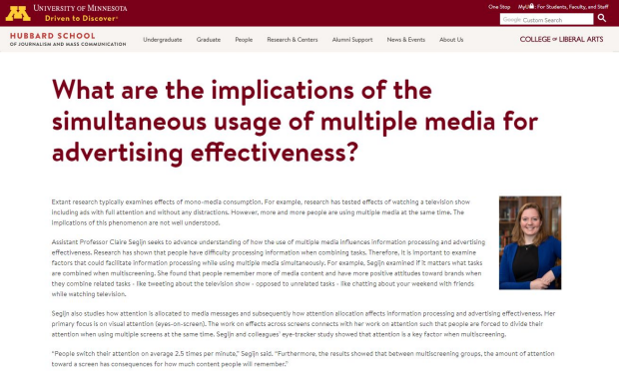
About me
▶ Dr. Claire M. Segijn
▶ Murphy Hall 308
▶ Office hours: Tu & Thu 1.00-2.00 pm + by appointment ▶ segijn@umn.edu
Email policy
▶ Email your TA first
▶ sections will be made available after first week
▶ Use ‘JOUR 4251’ in subject heading!
▶ Don’t expect a response outside of working hours
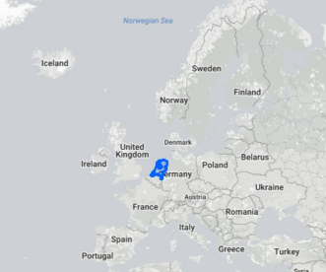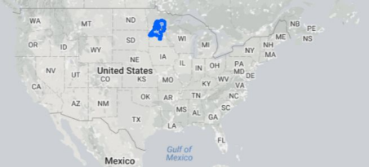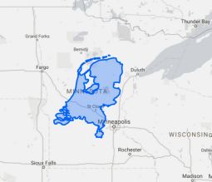
About your TAs
Weijia Shi
Office: Murphy Hall 400
Office hours: Tuesdays + Thursdays, 1:00-2:00 pm Email: shixx589@umn.edu
Ines Guanchez
Office: Murphy Hall 400
Office hours: guanc002@umn.edu
Email: Mondays + Wednesdays, 2:30-3:30 pm
Ida Darmawan
Office: Murphy Hall 400
Office hours: Tuesdays, noon-2:00 pm Email: darma002@umn.edu
About you
About the class
▶ T-TH, 2:30-3.45 pm, Murphy 130
▶ Lecture, discussion, and in-class activities ▶ Attendance
▶ You may use the 2010 or 2016 version of the book ▶ Used copies, library, rental, ebay, e-book
▶ 3 hour reserve loan at DIRC/Sevareid Library ▶ By next Thursday (Jan 30) first reading response due
▶ Disability or mental health accommodations (DRC) ▶ Mobile device policy/tech in the classroom ▶ Student misconduct, plagiarism, and fabrication
Expectations
▶ Be prepared
▶ Come to class having read the assigned materials ▶ Be ready to participate/engage in class
▶ Participate
▶ You are here to learn
▶ If no one volunteers, I will call on someone ▶ Ask questions
▶ Be curious; driven to discover
▶ Meet deadlines
▶ Be honest/integer
About the class
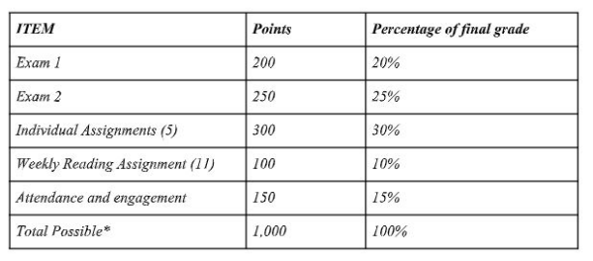*There may be extra credit opportunities in the form of research credits and tokens

Tokens
▶ All JOUR 4251 students receive 3 ‘tokens’
▶ Can be used for
▶ 24 hour deadline extension (2 tokens = 48 hours, etc.)
▶ CanNOT be used for
▶ Time extensions on exams or quizzes
▶ Extended time on in-class assignments / review questions
▶ Student needs to provide in writing that a token is being used (email TA) ▶ You do NOT need to ask permission upfront.
▶ Remaining tokens are worth 1 point each
▶ May not be gifted/sold/traded, etc. to other students
See syllabus for more information
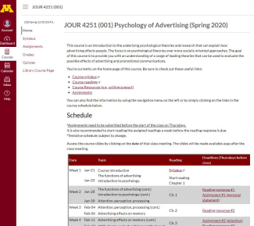
Course site
▶ Canvas
▶ Canvas.umn.edu
▶ Set up notifications (!)
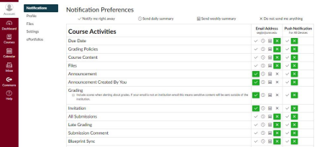
Questions?
About Advertising

Advertising
Any form of paid communication by an identified sponsor, aimed to inform and/or persuade target audiences about an organization.
Key words:
▶ Paid
▶ Placed
▶ Consumer-based
Advertising is a form of strategic communication
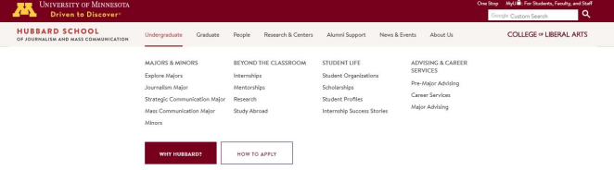
Advertising is a form of strategic communication
▶ Goal-oriented
▶ Long-term focus
▶ Proactive, not reactive
▶ Integrated into the organization
▶ Research and feedback can inform strategy
Brand
“The label with which to designate an individual product and differentiate it from competitors.” (p. 3)
Unique Selling Proposition
“Summary statement used to meaningfully differentiate the brand from the competition.” (p. 3)
This is the work of advertisers!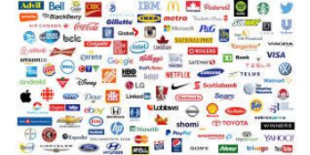
Why advertising?
1. Facilitates competition between companies 2. Way to communicate with customers
3. Key source of funding for media and other industries
To do
This week
▶ Review syllabus, canvas, materials, etc. and write down questions about anything that isn’t clear. Ask questions on Thursday.
▶ Activate notifications in Canvas (!)
Due by Jan 30 (before class starts)
▶ Submit assignment 1 (5 points)
▶ Personal statement + course agreement
▶ Start reading chapter 1 of the book
▶ Reading response due Jan 30 before class
Reading response (3-2-1)
Three learnings
1.
2.
3.
Two questions 1.
2.
One application 1.
Present it in bullet points + subheadings. Should be short and to the point.
No longer than 1 page (Times New Roman, 12). Word/ PDF format.
10 points per reading response
● 10 exceed expectations
● 8 met expectations
● 5 below expectations
● 2 incomplete
● 0 did not submit
Submit on Canvas.
Deadlines are on Thursdays before class start.
We do not accept late submissions + no make ups. 11 reading responses, 10 highest count.

